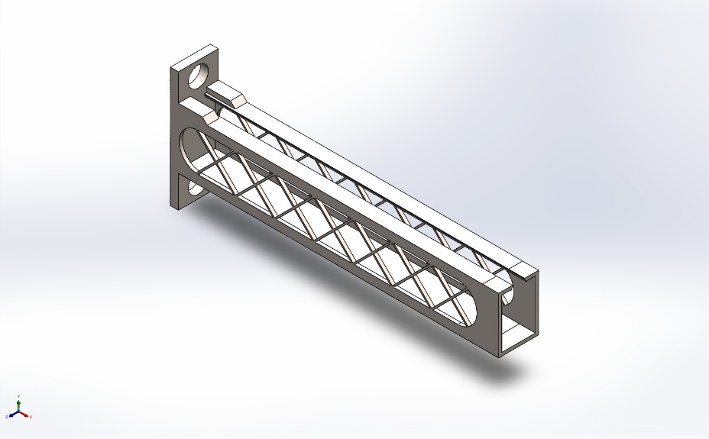
  Simulation of Cantilever Bracket
  Date: 07 June 2026
  Designer: Solidworks
  Study name: Static 3 from [Static 2 ]
  Analysis type: Static
  Table of Contents
  Description 1
  Assumptions 2
  Model Information 2
  Study Properties 3
  Units 3
  Material Properties 4
  Loads and Fixtures 5
  Connector Definitions 6
  Interaction Information 6
  Mesh information 7
  Sensor Details 12
  Resultant Forces 14
  Beams 14
  Study Results 15
  Conclusion 18

Description
No Data

Assumptions

Model Information

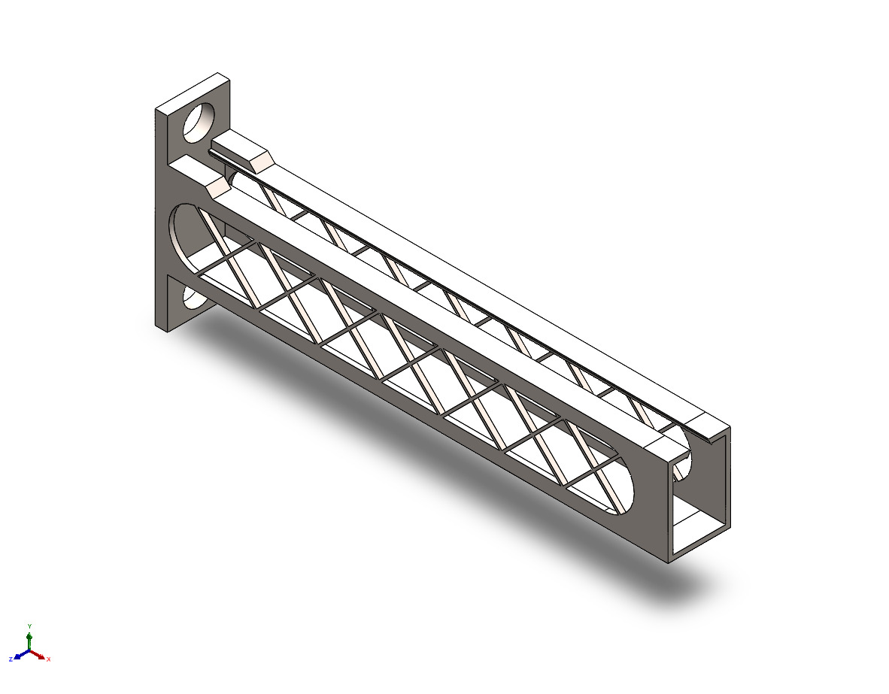
Model name: Cantilever Bracket
Current Configuration: Child Reborn
Solid Bodies
Document Name and Reference | Treated As | Volumetric Properties | Document Path/Date Modified
Mirror7  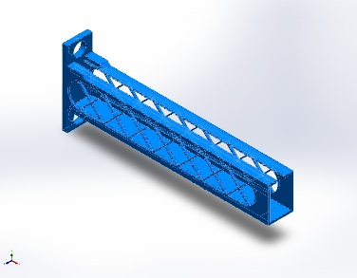 | Solid Body | Mass:269.821 kg  Volume:0.0350416 m^3  Density:7,700 kg/m^3  Weight:2,644.24 N | C:\Users\asus\Documents\Solidworks assignments\Chair\Cantilever Bracket.SLDPRT  Jun 7 10:47:26 2026

Study Properties
Study name | Static 3 from [Static 2 ]
Analysis type | Static
Mesh type | Solid Mesh
Thermal Effect: | On
Thermal option | Include temperature loads
Zero strain temperature | 298 Kelvin
Include fluid pressure effects from SOLIDWORKS Flow Simulation | Off
Solver type | Automatic
Inplane Effect: | Off
Soft Spring: | Off
Inertial Relief: | Off
Incompatible bonding options | Automatic
Contact penalty stiffness scale factor | 1
Large displacement | Off
Compute free body forces | On
Friction | Off
Use Adaptive Method: | Off
Result folder | SOLIDWORKS document (C:\Users\asus\Documents\Solidworks assignments\Chair)

Units
Unit system: | SI (MKS)
Length/Displacement | mm
Temperature | Kelvin
Angular velocity | Rad/sec
Pressure/Stress | N/m^2

Material Properties
Model Reference | Properties | Components
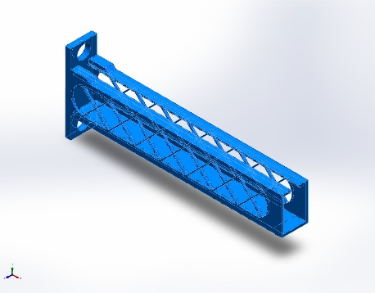 |  | SolidBody 2(Mirror7)(Cantilever Bracket)
  Name: | Alloy Steel
  Model type: | Linear Elastic Isotropic
  Default failure criterion: | Max von Mises Stress
  Yield strength: | 6.20422e+08 N/m^2
  Tensile strength: | 7.23826e+08 N/m^2
  Elastic modulus: | 2.1e+11 N/m^2
  Poisson's ratio: | 0.28
  Mass density: | 7,700 kg/m^3
  Shear modulus: | 7.9e+10 N/m^2
  Thermal expansion coefficient: | 1.3e-05 /Kelvin
Curve Data:N/A

Loads and Fixtures
Fixture name | Fixture Image | Fixture Details
Fixed-1 | 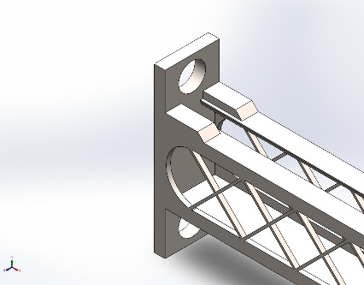
  Entities: | 1 face(s)
  Type: | Fixed Geometry
Resultant Forces
Components | X | Y | Z | Resultant
Reaction force(N) | -0.207025 | 4,196.02 | -0.129544 | 4,196.02
Reaction Moment(N.m) | 0 | 0 | 0 | 0

Load name | Load Image | Load Details
Force-1 | 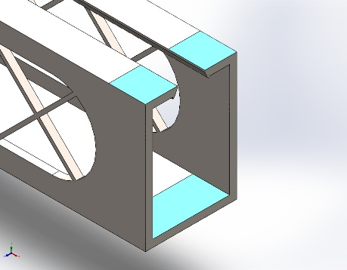
  Entities: | 3 face(s)
  Type: | Apply normal force
  Value: | 500 N
Gravity-1 | 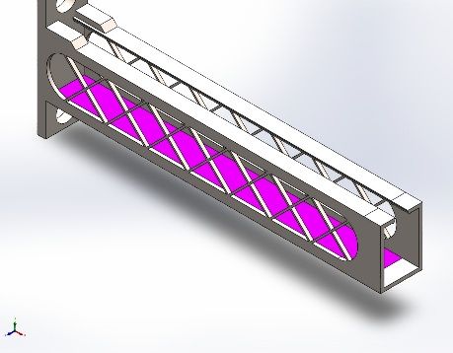
  Reference: | Face< 1 >
  Values: | 0 0 9.81
  Units: | m/s^2
Distributed Mass-1 | 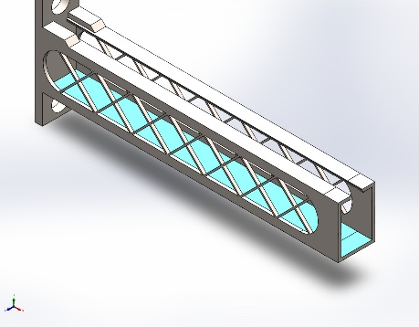
  Entities: | 2 face(s)
  Type: | Displacement (Direct transfer)
  Coordinate System: | Global cartesian coordinates
  Translation Values: | ---, ---, --- mm
  Rotation Values: | ---, ---, --- deg
  Reference coordinates: | 0 0 0 mm
  Remote Mass: | 5 kg
  Moment of Inertia: | 0,0,0,0,0,0 kg.m^2
  Components transferred: | NA

Connector Definitions
No Data

Interaction Information
No Data

Mesh information
Mesh type | Solid Mesh
Mesher Used: | Blended curvature-based mesh
Jacobian points for High quality mesh | 16 Points
Maximum element size | 275.576 mm
Minimum element size | 102.239 mm
Mesh Quality | High

Mesh information - Details
Total Nodes | 458961
Total Elements | 241739
Maximum Aspect Ratio | 9.2901
% of elements with Aspect Ratio < 3 | 95.2
Percentage of elements with Aspect Ratio > 10 | 0
Percentage of distorted elements | 0
Time to complete mesh(hh;mm;ss): | 00:00:35
Computer name:

Mesh Control Information:
Mesh Control Name | Mesh Control Image | Mesh Control Details
Control-1{1} | 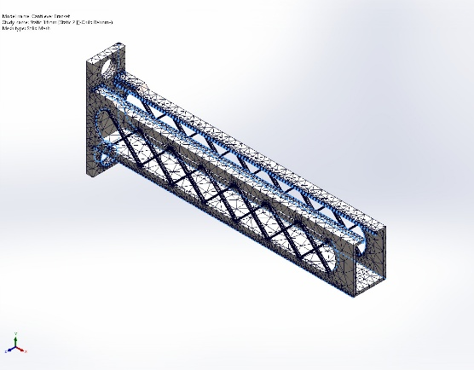
  Entities: | 25 edge(s)
  Units: | mm
  Size: | 4.8532
  Ratio: | 4.8532
Control-2{1} | 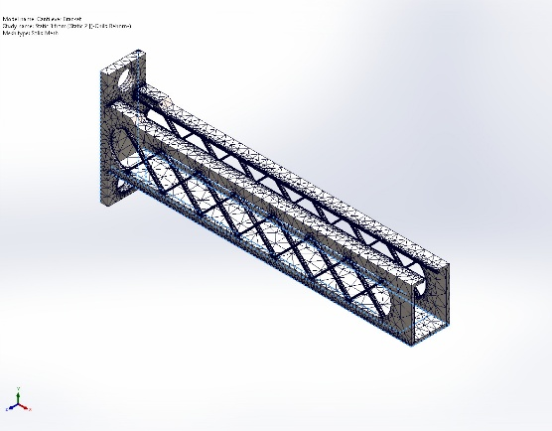
  Entities: | 23 edge(s)
  Units: | mm
  Size: | 28.5
  Ratio: | 28.5
Control-4{1} | 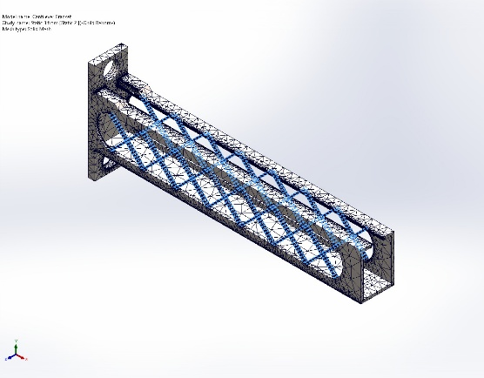
  Entities: | 224 edge(s), 1 face(s)
  Units: | mm
  Size: | 2.6846
  Ratio: | 2.6846

Mesh Quality Plots
Name | Type | Min | Max
Quality1 | Aspect Ratio | 1.016  Element: 188407 | 9.290  Element: 84912
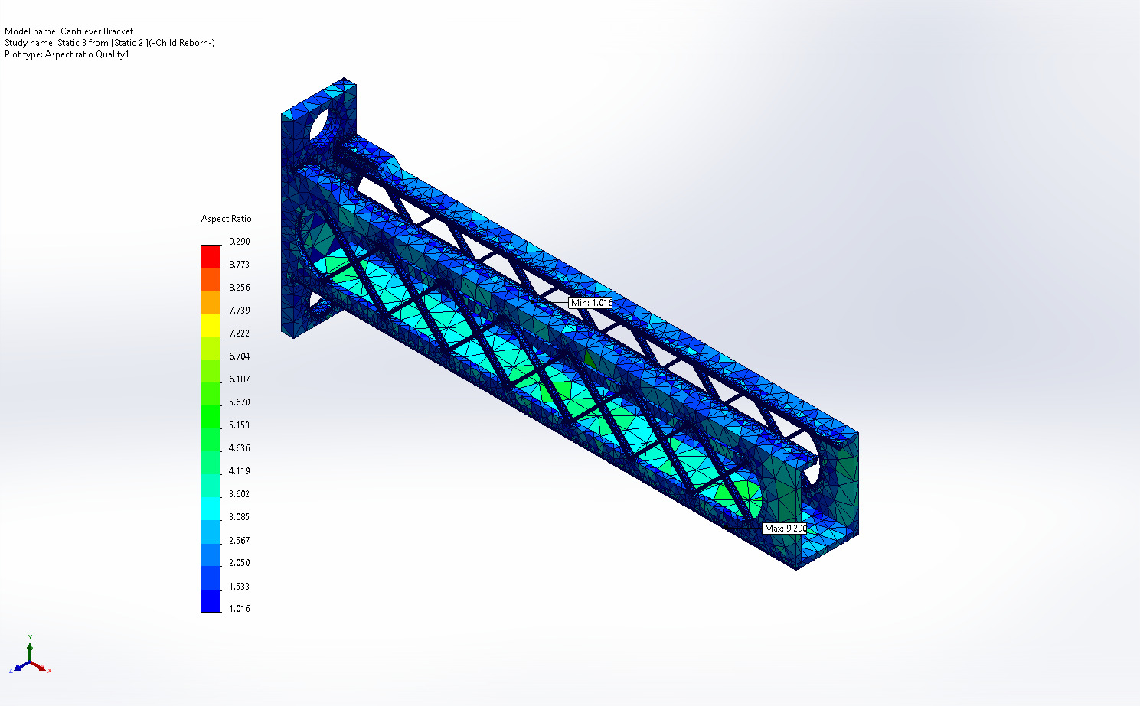
Cantilever Bracket-Static 3 from [Static 2 ]-Quality-Quality1

Name | Type | Min | Max
Diagnosis2 | Mesh Quality Diagnostics : Aspect Ratio | 1.016  Element: 188407 | 9.290  Element: 84912
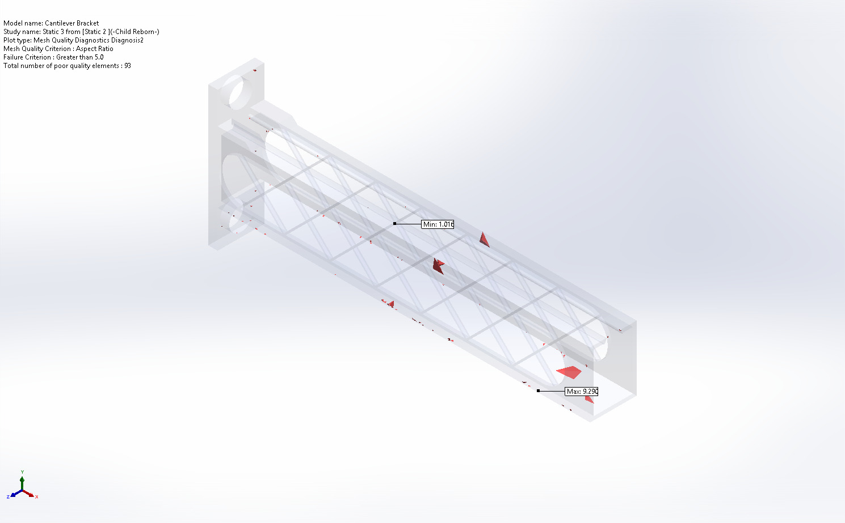
Cantilever Bracket-Static 3 from [Static 2 ]-Quality-Diagnosis2

Name | Type | Min | Max
Diagnosis3 | Mesh Quality Diagnostics : Jacobian ratio | 1.000e+00  Element: 126 | 1.939e+00  Element: 102880
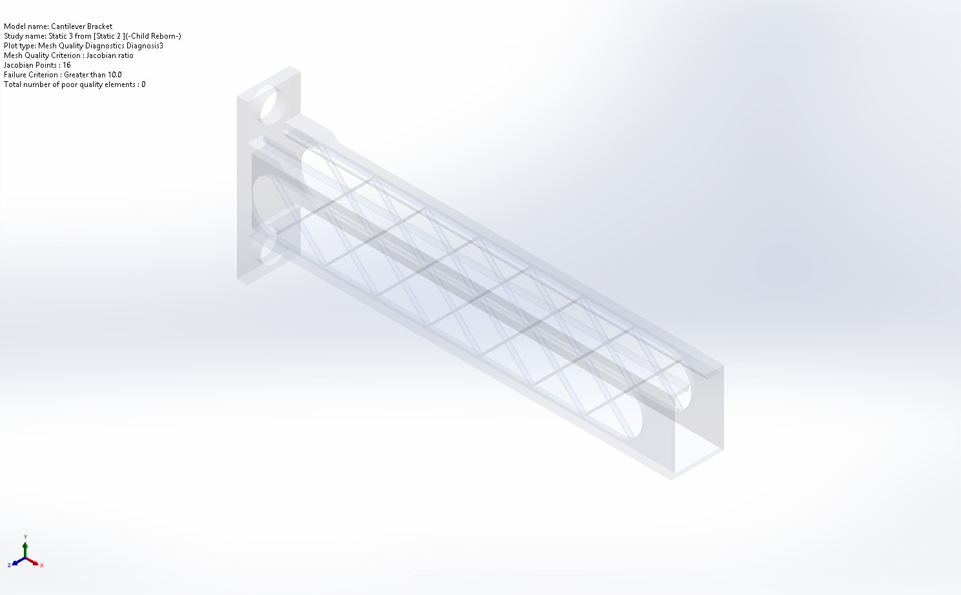
Cantilever Bracket-Static 3 from [Static 2 ]-Quality-Diagnosis3

Name | Type | Min | Max
Diagnosis4 | Mesh Quality Diagnostics : Element volume | 0.000  Element: 216710 | 0.000  Element: 164779
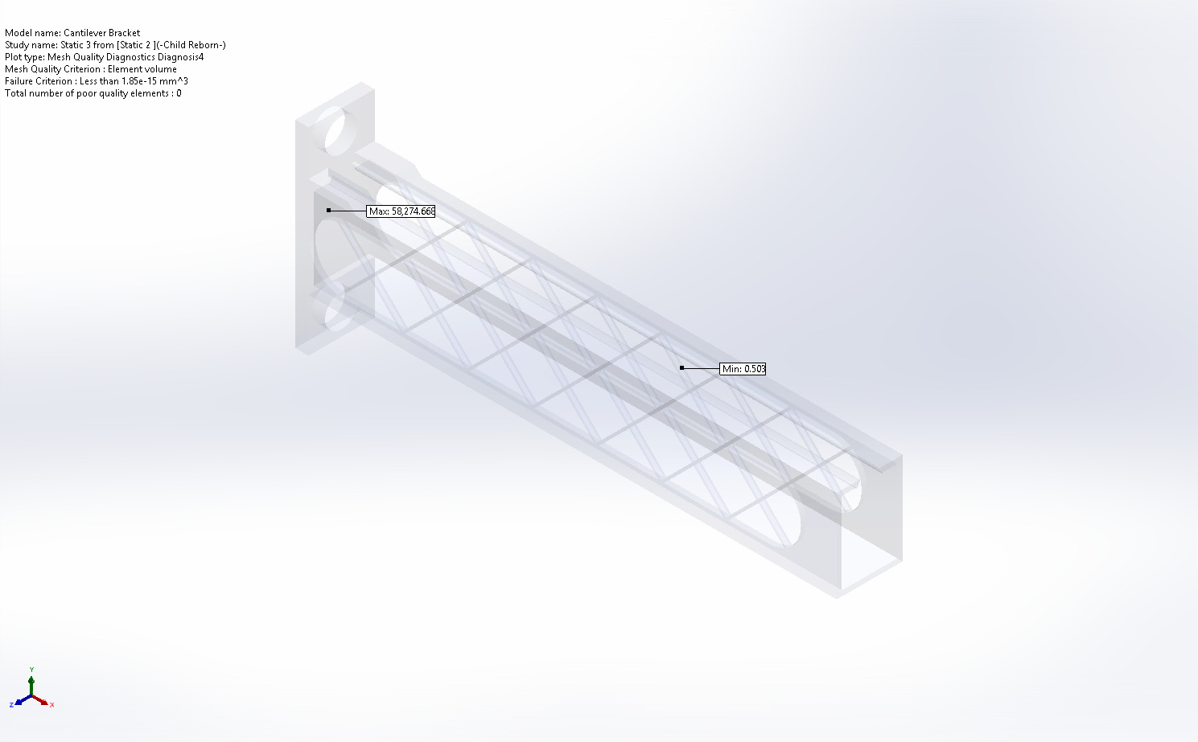
Cantilever Bracket-Static 3 from [Static 2 ]-Quality-Diagnosis4

Sensor Details

Sensor name | Location | Sensor Details
Mass1 | 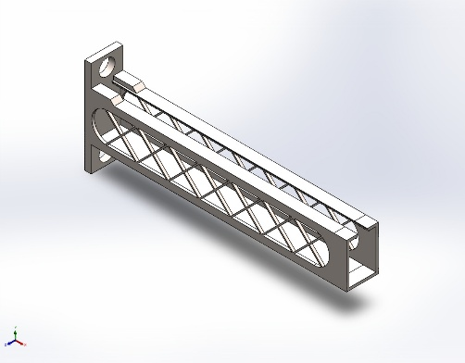 | Value : 41,695.41 g  Entities :  Result :Stress  Component :VON: von Mises Stress  Criterion :Model Max  Step Criterion : Across all Steps  Step No.:1  Alert Value: NA
Stress1 |  | Value : 10,851,667.000 N/m^2  Entities :  Result :Stress  Component :VON: von Mises Stress  Criterion :Model Max  Step Criterion : Across all Steps  Step No.:1  Alert Value: NA
Displacement1 |  | Value : 0.216 mm  Entities :  Result :Displacement  Component :URES: Resultant Displacement  Criterion :Model Max  Step Criterion : Across all Steps  Step No.:1  Alert Value: NA
Mass2 |  | Value : 41,695.41 g  Entities :  Result :Stress  Component :VON: von Mises Stress  Criterion :Model Max  Step Criterion : Across all Steps  Step No.:1  Alert Value: NA
Stress2 |  | Value : 10,851,667.000 N/m^2  Entities :  Result :Stress  Component :VON: von Mises Stress  Criterion :Model Max  Step Criterion : Across all Steps  Step No.:1  Alert Value: NA
Displacement2 |  | Value : 0.216 mm  Entities :  Result :Displacement  Component :URES: Resultant Displacement  Criterion :Model Max  Step Criterion : Across all Steps  Step No.:1  Alert Value: NA
Mass3 |  | Value : 41,695.41 g  Entities :  Result :Stress  Component :VON: von Mises Stress  Criterion :Model Max  Step Criterion : Across all Steps  Step No.:1  Alert Value: NA
Stress3 |  | Value : 10,851,667.000 N/m^2  Entities :  Result :Stress  Component :VON: von Mises Stress  Criterion :Model Max  Step Criterion : Across all Steps  Step No.:1  Alert Value: NA
Displacement3 |  | Value : 0.216 mm  Entities :  Result :Displacement  Component :URES: Resultant Displacement  Criterion :Model Max  Step Criterion : Across all Steps  Step No.:1  Alert Value: NA

Resultant Forces

Reaction forces
Selection set | Units | Sum X | Sum Y | Sum Z | Resultant
Entire Model | N | -0.207025 | 4,196.02 | -0.129544 | 4,196.02

Reaction Moments
Selection set | Units | Sum X | Sum Y | Sum Z | Resultant
Entire Model | N.m | 0 | 0 | 0 | 0

Free body forces
Selection set | Units | Sum X | Sum Y | Sum Z | Resultant
Entire Model | N | -1.38598 | 1,971.24 | 3.56959 | 1,971.25

Free body moments
Selection set | Units | Sum X | Sum Y | Sum Z | Resultant
Entire Model | N.m | 0 | 0 | 0 | 1e-33

Beams
No Data

Study Results

Name | Type | Min | Max
Stress1 | VON: von Mises Stress | 227.700N/m^2  Node: 34456 | 10,851,667.000N/m^2  Node: 329
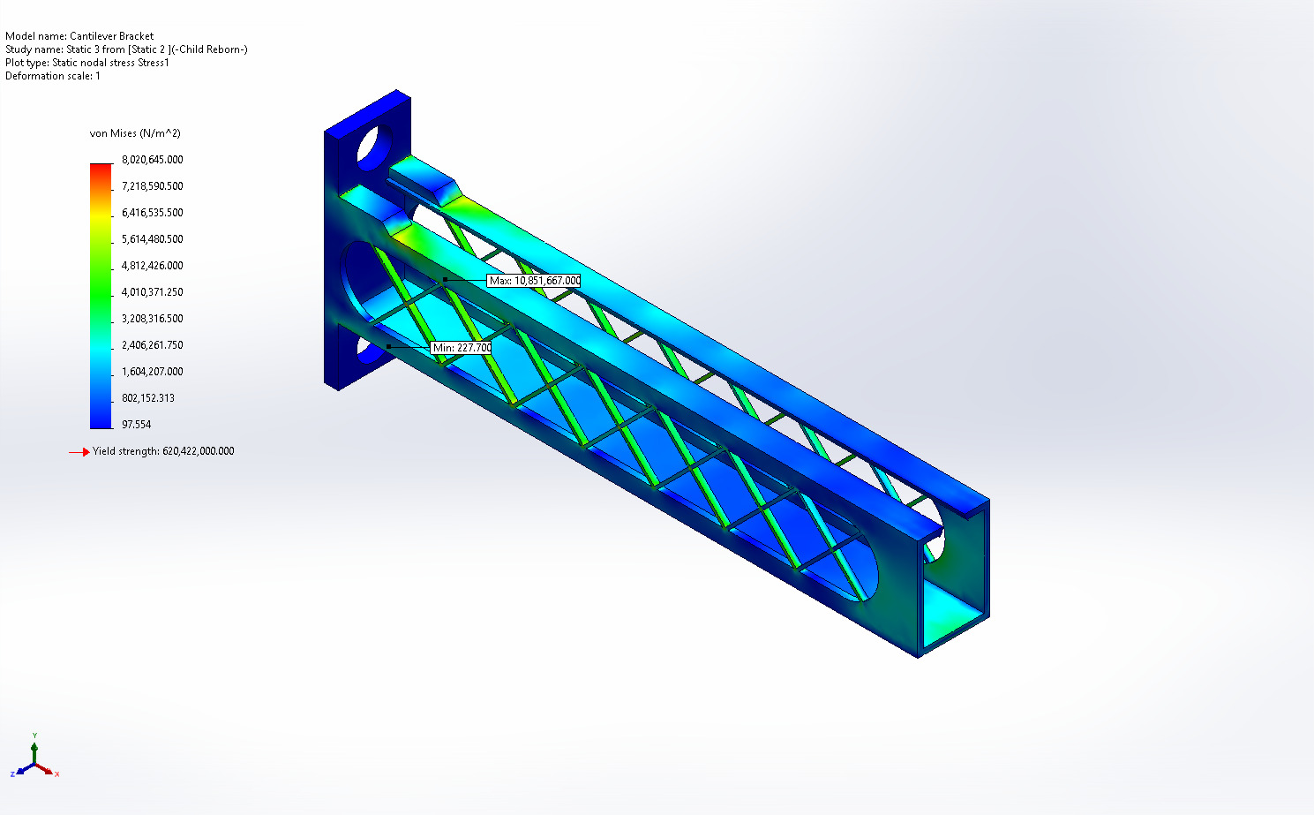
Cantilever Bracket-Static 3 from [Static 2 ]-Stress-Stress1

Name | Type | Min | Max
Displacement1 | URES: Resultant Displacement | 0.000mm  Node: 30 | 0.216mm  Node: 361
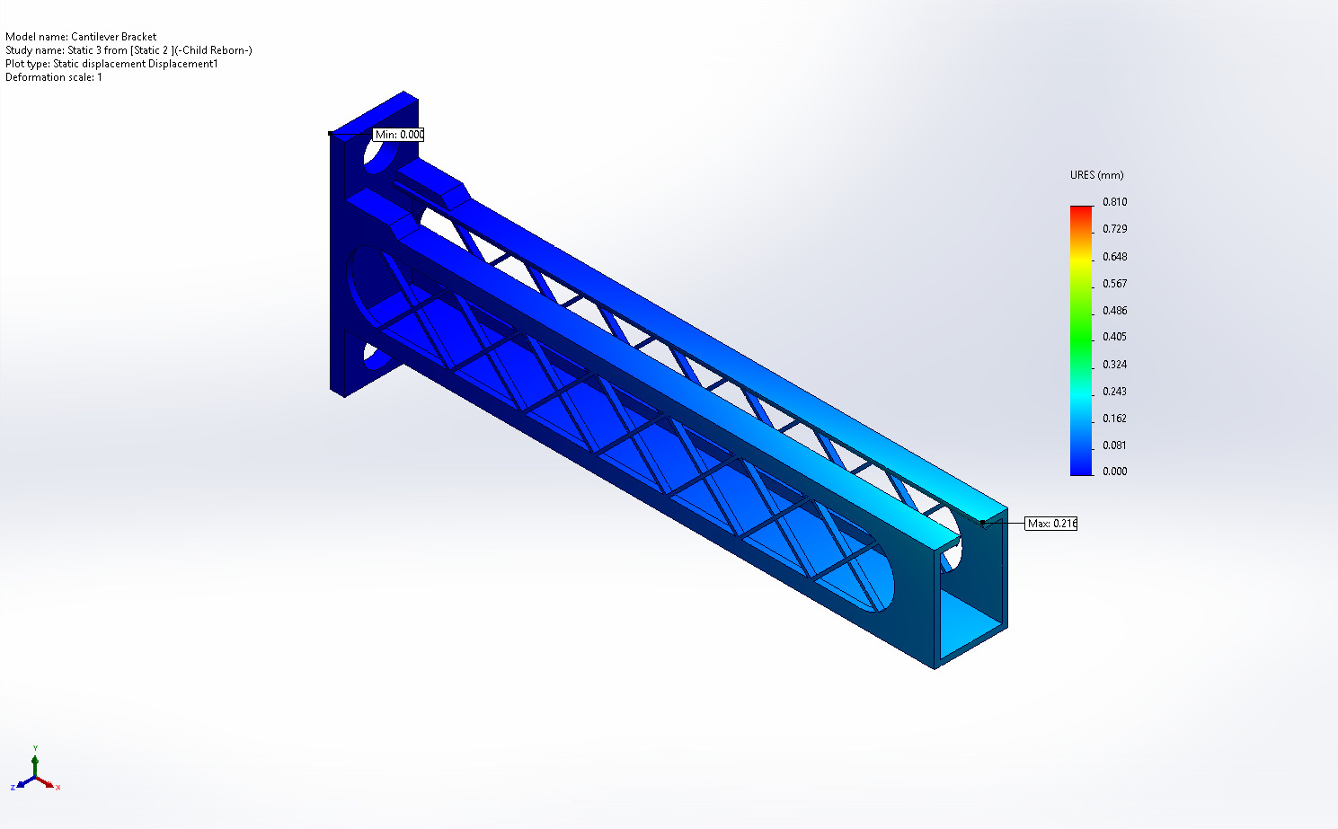
Cantilever Bracket-Static 3 from [Static 2 ]-Displacement-Displacement1

Name | Type | Min | Max
Strain1 | ESTRN: Equivalent Strain | 0.000  Element: 173005 | 0.000  Element: 222467
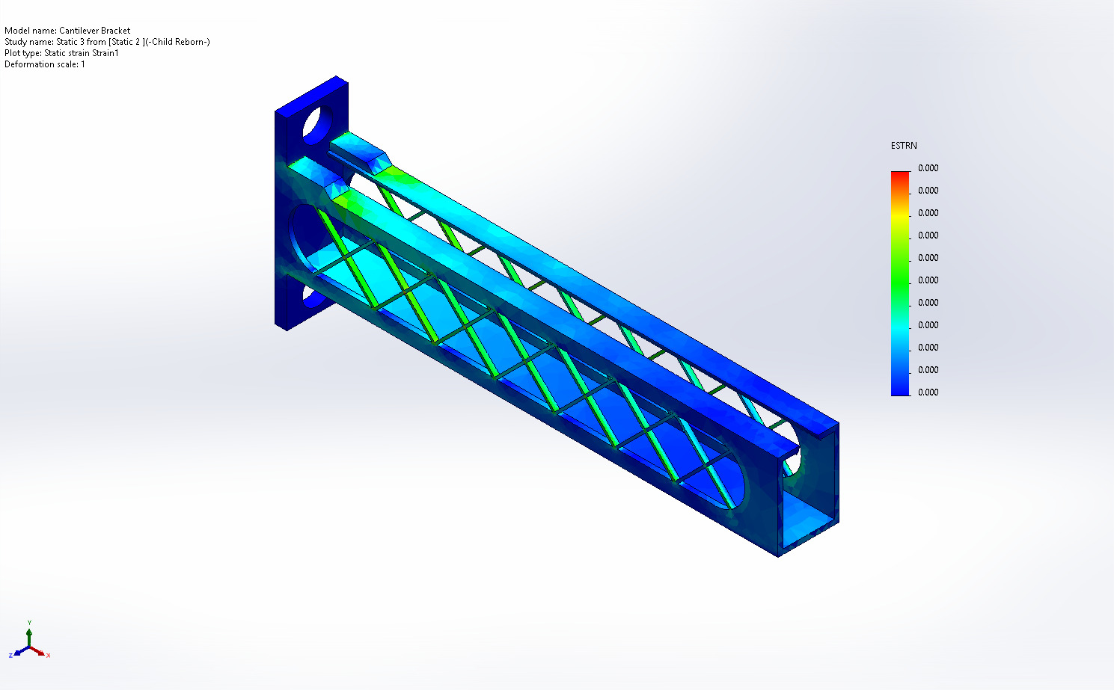
Cantilever Bracket-Static 3 from [Static 2 ]-Strain-Strain1

Name | Type
Design Insight1 | Design Insight
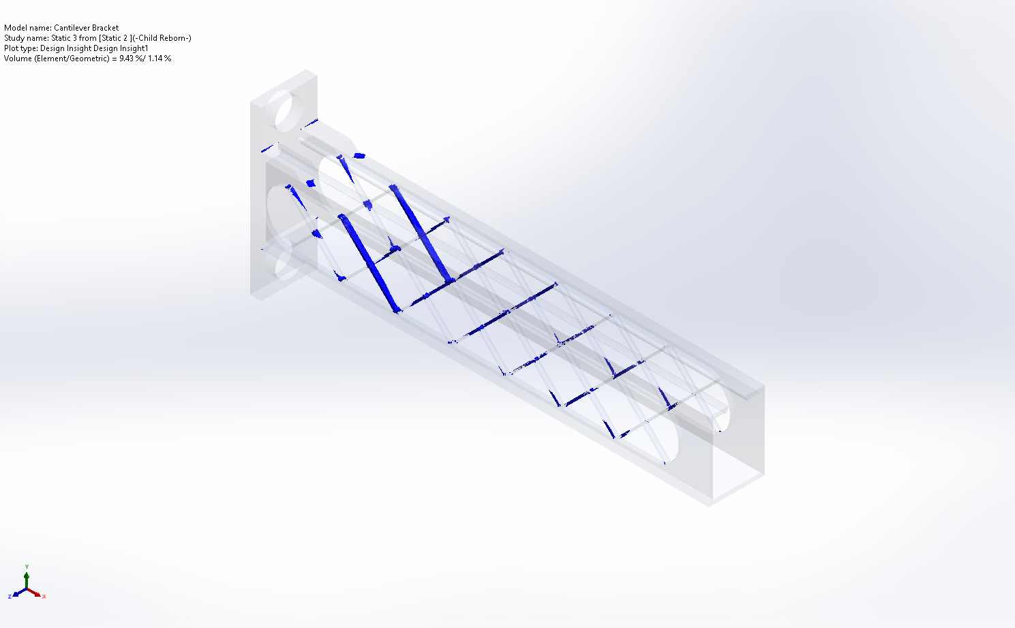
Cantilever Bracket-Static 3 from [Static 2 ]-Design Insight-Design Insight1

Conclusion

